1. **Exploring experiments and data**

Select the third-year undergraduate students who have the same level of familiarity with the experimental scene as volunteers to ensure that they have the same educational background and age characteristics, and using the Purdue University Mental Cut Test (MCT) of Purdue University, the subjects were homogenized and divided into 4 groups (The specific grouping can be seen in the file “Experimental personnel’s spatial cognitive ability data”). When grouping, the test scores of the subjects were used as the main reference index, so that the mean value of the overall spatial cognitive ability test scores between the groups was the same, the distribution of men and women was even, and the age distribution was similar, so as to ensure that the test process of each group was the same except for the independent variables. Then, two different indoor shopping malls near the school were selected as the test sites. The subjects walked along the designed route from the starting point to the end point in a “shopping” state. After reaching the end point, the subjects independently recalled and recorded the POIs they saw during the trip. Finally, the collected experimental data are cleaned and sorted, and the main influencing factors of indoor POI significance are determined through the questionnaire survey of the subjects. The test data are shown in Table 1(This table can also be found in the file “Information statistics table of the recall elements and influencing factors of the verification experiment in Starlight Square”). The number of recalled persons(The survey results for recall can be seen in the file “Popularity Questionnaire Results Form”) and popularity in Table 1 are calculated based on the average of the questionnaire survey results of 118 test personnel, and the spatial location, uniqueness and relative scale are the results of the field investigation of the test personnel.

Tab.1 Information statistics table of the recall elements and influencing factors of the verification experiment in Starlight Square

|  |  |  |  |  |  |
| --- | --- | --- | --- | --- | --- |
| **POI** | **Recall** | **Popularity** | **Location** | **Uniqueness** | **Size** |
|  |
| Adidas | 89 | 7.8 | Entrance | No | Middle |  |
| Nike | 72 | 7.6 | Channel | No | Small |  |
| Watsons | 67 | 6.3 | Entrance | No | Middle |  |
| MUJI | 59 | 6.2 | Multi-channel intersection | No | Small |  |
| UNIQLO | 55 | 7 | Channel corners | No | Large |  |
| ANTA | 52 | 7.5 | Channel | No | Middle |  |
| New balance | 48 | 6.6 | Elevator entrance | No | Small |  |
| Yidiandian | 44 | 5.3 | Entrance | Yes | Small |  |
| Puma | 43 | 5.7 | Multi-channel intersection | No | Middle |  |
| Shuyi | 42 | 6.6 | Channel | Yes | Small |  |
| Vans | 38 | 5.8 | Channel corners | No | Small |  |
| Juewei | 36 | 7.2 | Channel | No | Small |  |
| CONVERSE | 34 | 6.1 | Multi-channel intersection | No | Small |  |
| Ayogurtcow | 32 | 6.3 | Channel | Yes | Small |  |
| LDK | 32 | 5.5 | Multi-channel intersection | No | Middle |  |
| Fila | 30 | 5.2 | Channel | No | Middle |  |
| Hotwind | 30 | 4.4 | Entrance | No | Middle |  |
| Westlink | 29 | 4.2 | Entrance | No | Large |  |
| Apple | 28 | 7.2 | Channel | No | Small |  |
| NBA | 25 | 5.6 | Multi-channel intersection | No | Small |  |
| Dickes | 20 | 4.9 | Channel | Yes | Small |  |
| Huawei | 19 | 7.1 | Channel | No | Small |  |
| Zhouheiya | 19 | 6.4 | Channel | Yes | Small |  |
| Happylemon | 18 | 4.4 | Channel | Yes | Small |  |
| Keds | 17 | 4.2 | Multi-channel intersection | No | Small |  |
| GXG | 16 | 3.9 | Multi-channel intersection | No | Small |  |
| UR | 15 | 3.6 | Elevator entrance | No | Middle |  |
| Purcotton | 15 | 3.7 | Elevator entrance | No | Middle |  |
| Takoyaki | 13 | 4.1 | Channel | Yes | Small |  |
| Sanfu | 12 | 4.5 | Channel | No | Middle |  |
| Kappa | 12 | 5.1 | Channel | No | Small |  |
| Boy | 11 | 4.1 | Channel | Yes | Small |  |
| Shuajiazj | 11 | 4 | Channel | No | Small |  |
| SKECHERS | 11 | 3.8 | Channel corners | No | Small |  |
| YEARCON | 10 | 4.3 | Channel | No | Middle |  |
| Bafangyudan | 10 | 3.4 | Channel | Yes | Small |  |
| Zippo | 10 | 3.8 | Channel corners | No | Small |  |
| Bingo drinks | 9 | 4.4 | Multi-channel intersection | No | Small |  |
| Lee | 9 | 3.7 | Multi-channel intersection | No | Small |  |
| O.C.E | 7 | 3.6 | Multi-channel intersection | No | Small |  |
| ANTA kids | 7 | 5.1 | Channel | No | Small |  |
| Gialen | 7 | 3.7 | Multi-channel intersection | No | Small |  |
| RED DRAGONFLY | 7 | 4.3 | Channel | No | Middle |  |
| CR Vanguard | 6 | 4 | Channel corners | No | Small |  |
| Dan nong | 6 | 2.4 | Channel | Yes | Small |  |
| Ugly crispy meat | 5 | 3.3 | Channel | Yes | Small |  |
| AK club | 5 | 2.9 | Multi-channel intersection | No | Small |  |
| Bowl chicken | 5 | 4.2 | Channel | Yes | Small |  |
| Weizifu | 5 | 3.8 | Channel | Yes | Small |  |
| PEACEBIRD | 5 | 4.1 | Channel corners | No | Middle |  |
| Meiweimeike | 5 | 3.5 | Channel corners | Yes | Small |  |

1. **Processing of sample data**
2. Classification of recalled person-times: Using natural discontinuous clustering to process POI recalled person-times of Starlight Square, POIs of different levels can be obtained. This method classifies POIs with recalls of 42 and above as level 1, POIs between 15 and 42 as level 2, and POIs below 15 as level 3. The results are shown in the "Grading" column of Table 3(This table can also be found in the file “Information statistics table of the recall elements and influencing factors of the verification experiment in Starlight Square”).
3. POI popularity: Popularity refers to users' familiarity with the indoor POI brand, and it was tallied through a user-facing questionnaire. During the online questionnaire survey, the popularity of POIs was categorised from low to high on a scale of 1–10, and users were asked to score each POI individually. Then, the scores collected for each POI were averaged as its significance value.
4. Spatial location: The location of a POI refers to the influence of different locations in the interior space on the salience of the POI. In this study, we classify location-influencing factors into five levels, including access, access corners, multiple access intersections, lift entrances and entrances, corresponding to quantitative values of 1–5, respectively.
5. Uniqueness: The uniqueness of a POI refers to some of the unique features that the POI has that can attract the user's attention. In the exploration experiment, based on communication with users after the experiment, we found that many users mentioned the name and decoration of the POI and the difference between the POI and its surrounding features, which greatly affects their memory of the POI. The uniqueness of the POI was divided into four categories, namely, “nonunique”, “uniqueness of name”, “uniqueness of decoration” and “uniqueness of features”.
6. Relative scale: The relative size of the POI is collected by measuring the length () and height () of the store near the aisle. By calculating the visual area (), the visual area of the POI in the indoor space is divided into three grades, small, medium, and large, according to the gradient and quantified as 1–3, respectively.

The spatial location distribution, uniqueness and relative scale of POI are quantified according to the attribute refinement system shown above, and the quantified results are shown in Table 2.

Table 2. Influencing factor information statistics table

|  |  |  |  |  |  |
| --- | --- | --- | --- | --- | --- |
| **POI** | **Classification** | **Popularity** | **Localtion** | **Uniqueness** | **Size** |
| Adidas | 1 | 8 | 5 | 1 | 2 |
| Nike | 1 | 8 | 1 | 1 | 1 |
| Watsons | 1 | 6 | 5 | 1 | 2 |
| MUJI | 1 | 6 | 3 | 1 | 1 |
| UNIQLO | 1 | 7 | 2 | 1 | 3 |
| ANTA | 1 | 8 | 1 | 1 | 2 |
| New balance | 1 | 7 | 4 | 1 | 1 |
| Yidiandian | 1 | 5 | 5 | 2 | 1 |
| Puma | 1 | 6 | 3 | 1 | 2 |
| Shuyi | 1 | 7 | 1 | 2 | 1 |
| Vans | 2 | 6 | 2 | 1 | 1 |
| Juewei | 2 | 7 | 1 | 1 | 1 |
| CONVERSE | 2 | 6 | 3 | 1 | 1 |
| Ayogurtcow | 2 | 6 | 1 | 2 | 1 |
| LDK | 2 | 6 | 3 | 1 | 2 |
| Fila | 2 | 5 | 1 | 1 | 2 |
| Hotwind | 2 | 4 | 5 | 1 | 2 |
| Westlink | 2 | 4 | 5 | 1 | 3 |
| Apple | 2 | 7 | 1 | 1 | 1 |
| NBA | 2 | 6 | 3 | 1 | 1 |
| Dickes | 2 | 5 | 1 | 3 | 1 |
| Huawei | 2 | 7 | 1 | 1 | 1 |
| Zhouheiya | 2 | 6 | 1 | 2 | 1 |
| Happylemon | 2 | 4 | 1 | 3 | 1 |
| Keds | 2 | 4 | 3 | 1 | 1 |
| GXG | 2 | 4 | 3 | 1 | 1 |
| UR | 2 | 4 | 4 | 1 | 2 |
| Purcotton | 2 | 4 | 4 | 1 | 2 |
| Takoyaki | 3 | 4 | 1 | 2 | 1 |
| Sanfu | 3 | 5 | 1 | 1 | 2 |
| Kappa | 3 | 5 | 1 | 1 | 1 |
| Boy | 3 | 4 | 1 | 2 | 1 |
| Shuajiazj | 3 | 4 | 1 | 1 | 1 |
| SKECHERS | 3 | 4 | 2 | 1 | 1 |
| YEARCON | 3 | 4 | 1 | 1 | 2 |
| Bafangyudan | 3 | 3 | 1 | 3 | 1 |
| Zippo | 3 | 4 | 2 | 1 | 1 |
| Bingo drinks | 3 | 4 | 3 | 1 | 1 |
| Lee | 3 | 4 | 3 | 1 | 1 |
| O.C.E | 3 | 4 | 3 | 1 | 1 |
| ANTA kids | 3 | 5 | 1 | 1 | 1 |
| Gialen | 3 | 4 | 3 | 1 | 1 |
| RED DRAGONFLY | 3 | 4 | 1 | 1 | 2 |
| CR Vanguard | 3 | 4 | 2 | 1 | 1 |
| Dan nong | 3 | 2 | 1 | 2 | 1 |
| Ugly crispy meat | 3 | 3 | 1 | 3 | 1 |
| AK club | 3 | 3 | 3 | 1 | 1 |
| Bowl chicken | 3 | 4 | 1 | 2 | 1 |
| Weizifu | 3 | 4 | 1 | 2 | 1 |
| PEACEBIRD | 3 | 4 | 2 | 1 | 2 |
| Meiweimeike | 3 | 4 | 2 | 2 | 1 |

1. **Construction of POI saliency model based on Fisher discriminant method**

The FDA-based POI significance evaluation model was established by using SPSS 25.0 software using the data in Table 2.（Please see the file “SPSS data analysis instructions ” for details.）

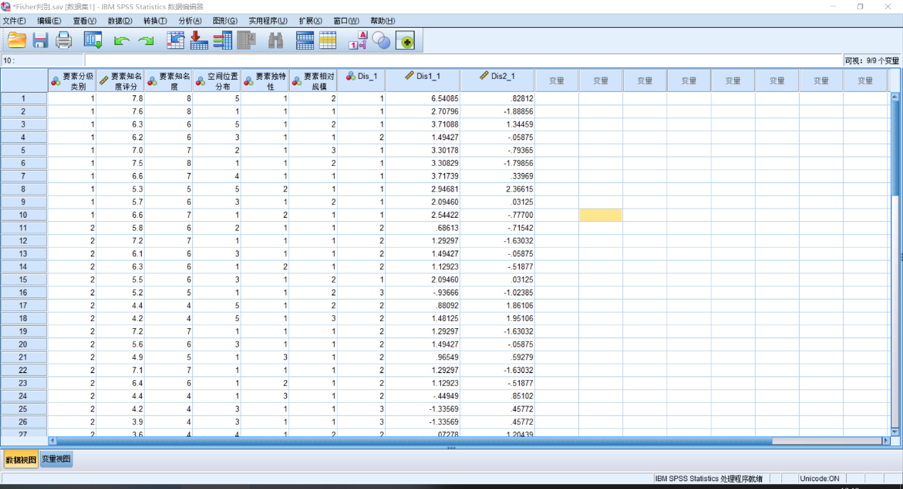

(In this table, “要素分级类别” means “Feature Grading Category”, “要素知名度评分” means “Element popularity score”, “空间位置分布” means “Spatial location distribution”, “要素独特性” means “Element uniqueness”, “要素相对规模” means “Element relative size”)

